## Module – Reactjs ,Components , states ,props

1] Create Hello World React program show below.

Index.js

import React from 'react';

import ReactDOM from 'react-dom';

import './App.css';

function App() {

  return (

    <div className="App">

      <h1>react app</h1>

      <img src="https://upload.wikimedia.org/wikipedia/commons/a/a7/React-icon.svg" alt="React Logo" className="logo" />

      <h1>Hello World</h1>

    </div>

  );

}

ReactDOM.render(<App />, document.getElementById('root'));

root.render(

  <React.StrictMode>

    <App />

  </React.StrictMode>

);

css

body {

  margin: 0;

  padding: 0;

  display: flex;

  justify-content: center;

  align-items: center;

  height: 100vh;

  background-color: black;

}

.App {

  text-align: center;

  color: cyan;

}

.logo {

  width: 100px;

  margin-bottom: 20px;

}

Output:

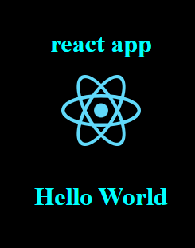

**2]Create counter app program shown below.**

Step 1: Set Up Your ReacStep 1: Set Up Your React App

npx create-react-app counter-app

cd counter-app

npm start

### Step 2: Create the Counter Component

import React, { useState } from 'react';

const Counter = () => {

  const [count, setCount] = useState(0);

  return (

    <div style={{ textAlign: 'center', marginTop: '50px' }}>

      <h1>Counter App</h1>

      <h2>{count}</h2>

      <button onClick={() => setCount(count + 1)} style={{ marginRight: '10px', padding: '10px', backgroundColor: 'green', color: 'white' }}>Increment</button>

      <button onClick={() => setCount(count - 1)} style={{ padding: '10px', backgroundColor: 'red', color: 'white' }}>Decrement</button>

    </div>

  );

};

export default Counter;

### Step 3: Use the Counter Component

import Counter from "./Counter";

function App() {

  return (

    <div>

      <Counter/>

    </div>

  );

}

export default App;

### Step 4: Run Your App

npm start

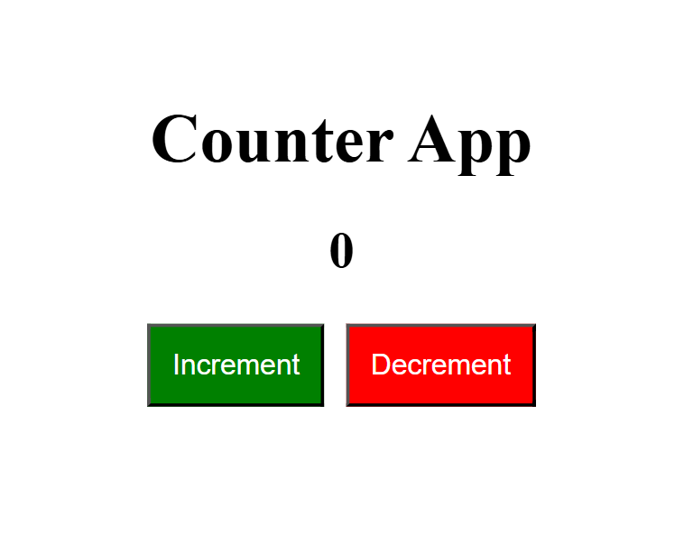**3] Create Login Lout React program as below**

Create the Layout Components

Navigation Component

import React from 'react';

const Navigation = ({ isLoggedIn, handleLogin }) => {

  return (

    <nav style={{ padding: '10px', backgroundColor: 'orange' , width: '200px', height:'50px',}}>

      <h2>Navigation</h2>

      <button onClick={handleLogin} style={{ padding: '10px', margin: '10px',marginLeft:'150px', markerEnd:'200px' }}>

        {isLoggedIn ? 'Logout' : 'Login'}

      </button>

    </nav>

  );

};

export default Navigation;

Public Views Component

Create a file named PublicViews.js:

import React from 'react';

const PublicViews = () => {

  return (

    <div>

      <h2>Public Views</h2>

    </div>

  );

};

export default PublicViews;

Private Views Component

Create a file named PrivateViews.js:

import React from 'react';

const PrivateViews = () => {

  return (

    <div>

      <h2>Private Views</h2>

    </div>

  );

};

export default PrivateViews;

Footer Component

Create a file named Footer.js:

import React from 'react';

const Footer = () => {

  return (

    <footer style={{ padding: '10px', backgroundColor: 'green', marginTop: '20px', width: '200px' }}>

      <p>Footer</p>

    </footer>

  );

};

export default Footer;

### Create the Main App Component

import React, { useState } from 'react';

import Navigation from './Navigation';

import PublicViews from './PublicViews';

import PrivateViews from './PrivateViews';

import Footer from './Footer';

function App() {

  const [isLoggedIn, setIsLoggedIn] = useState(false);

  const handleLogin = () => {

    setIsLoggedIn(!isLoggedIn);

  };

  return (

    <div className="App">

      <Navigation isLoggedIn={isLoggedIn} handleLogin={handleLogin} />

      {isLoggedIn ? <PrivateViews /> : <PublicViews />}

      <Footer />

    </div>

  );

}

export default App;

